Carousell Dispute Agent: Project Brief
Oct 25, 2026 · @Jonathan

Summary
We will build an AI agent that helps Carousell Singapore's support team settle "significantly not as described" disputes on second-hand items sold between individuals. The agent reads the listing, the buyer's complaint and the chat, checks them against Carousell's Buyer Protection policy using RAG, and recommends an outcome with reasons and policy citations. A Carousell staff member makes the final decision.
This is a BC3415 group project (40% of the module grade) submitted under Option A: a working prototype, a 3 to 5 minute demo video and a GitHub repo. A "what if" feature, re-judging past disputes under a proposed policy change, is a stretch goal.

Business problem
Carousell's Buyer Protection only works if buyers trust it, and that depends on settling "not as described" disputes fairly and quickly. Deciding whether a second-hand item matches its listing is a judgement call. Carousell's own policy separates real problems (missing parts, undisclosed defects, wrong model) from minor differences such as "light pink versus rose pink".
Three things make these disputes hard:
- Condition is subjective. "Good condition" or "minor scratches" means different things to different people.
- Both sides are individuals, not businesses. Listings and complaints are vague, and ordinary sellers can miss the 24-hour response deadline and lose by default.
- Evidence is scattered. The listing text and photos, the buyer's photos and the chat history all have to be read together.
If disputes lean too far towards buyers, honest sellers lose items and money. If they lean too far towards sellers, buyers stop trusting the 'Buy' button and pay outside the platform, where most scams happen.
Our solution: an AI agent that compares what the listing promised with what the buyer reports, checks the gap against Carousell's policy, and recommends an outcome with reasons and citations. Staff decide faster and more consistently, and unclear cases are flagged for a person to review.

Why Carousell
This problem only exists on marketplaces where individuals sell used goods to each other, which meets the professor's requirement that the problem be unique to one industry. A bank or a hedge fund has no listings or returns. Shopee and Lazada sell mostly new goods from businesses, and Shopee has already said it uses an AI engine for its own return disputes (Sea Q4 2024 earnings call).
Evidence | What it shows | Source
Carousell had 29.0% of e-commerce scam cases in Singapore in 2025, ahead of Facebook Marketplace at 22.2% | Trust is Carousell's biggest problem | SPF Annual Scam and Cybercrime Brief 2025
Carousell scam cases rose 17.1% to 1,555 in the first half of 2026 | The problem is growing | SPF Mid-Year Brief 2026
MHA tracks Carousell's safety features; 2,476 scam reports in 2023 | The government watches Carousell closely | MHA safety ratings: Carousell
Buyer Protection covers only 'Buy' button payments, and payment is held during a dispute | Carousell wants buyers inside the protected flow | Carousell: What is Buyer Protection?
eBay sellers report buyers misusing "not as described" claims on used goods | The dispute type is a known problem in second-hand marketplaces | eBay Community thread
Carousell's published AI work covers listings, car search, phone checks and fraud flags, not disputes | A gap we can fill | Google Cloud case study, OneShift
Limit to state openly: most scams happen outside Buyer Protection, through bank transfers and pre-orders, so the agent does not stop scams directly. Our argument is that fair, fast disputes make the protected 'Buy' button worth using. We found no public figures on Carousell's dispute volume or outcomes.

Users and today's process
The main user is Carousell Singapore's support team, who decide disputes that buyers and sellers cannot settle themselves. Buyers and sellers benefit indirectly through faster, better-explained decisions.
How a Singapore dispute works today (Carousell dispute overview, refund/return requests):
- The buyer raises a dispute from the Order Details page within the earliest of three deadlines, one of which is 2 days after the item shows as delivered.
- The seller has 24 hours to accept or offer something else (a partial refund, or a return).
- The buyer has 24 hours to accept the seller's offer.
- If they don't agree, the dispute goes to Carousell, whose support team emails both sides within 24 hours.
- Both sides submit evidence. Whoever misses an evidence deadline loses the dispute.
- Carousell decides. The buyer's payment is held until then.
What counts as "significantly not as described" (Buyer Protection and Certified Refund Policy):
Covered | Not covered
Different size, colour, model or version | "Materially similar with subjective and non-significant variations"
Missing parts | Example: listed as light pink, received as rose pink
Defects the seller didn't mention | Payments made outside the app (cash, bank transfer)
These details come from search snippets of Carousell's help pages, which blocked automated reading. Someone must read the full pages by hand before we rely on them.

Proposed solution
The agent turns a dispute case into a recommended decision that a staff member can check quickly. Features, in build order:
Feature | What it does | Priority
Case intake | Loads the listing (title, description, condition, photos), the buyer's complaint and photos, the chat and the delivery status | Must have
Eligibility check | Paid with the 'Buy' button? Within the deadline? Which dispute reason? | Must have
Claim matching | Lists what the listing promised and what the buyer says is wrong, then matches them. Example: "listing says 'comes with charger'; buyer says no charger → missing part" | Must have
Policy check (RAG) | Finds the relevant Carousell policy clause and decides whether each gap is "significant" or a minor difference | Must have
Recommendation | Full refund with return, partial refund, or reject, with a confidence level, reasons and policy citations | Must have
Escalation and follow-up questions | Sends unclear cases to a person and suggests what evidence to ask for, such as "photo of the serial number" | Must have
Message drafts | Drafts the decision messages to the buyer and the seller | Should have
Photo checking | A vision model compares listing photos with the buyer's photos | Nice to have
What-if policy test | Re-judges past disputes under a proposed rule change and reports how many outcomes flip | Stretch
The agent never decides alone: every recommendation goes to a staff member, who approves or overrides it.

How it works
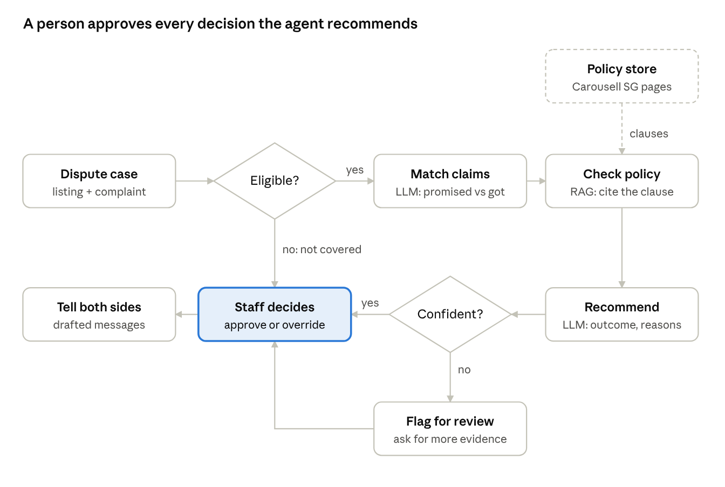
agent workflow · 6 steps, 2 decisions
The agent is a LangGraph workflow. It pauses at "Staff decides" until a person approves or overrides, and ineligible cases go straight to staff with a "not covered" note.
Part | Tool | Course link
Agent workflow, pause for human approval | LangGraph (Python) | AI agents
Claim matching, recommendation, message drafts | LLM API (Gemini or OpenAI) with structured JSON output | GenAI API programming
Policy retrieval with citations | Embeddings + ChromaDB | RAG
Photo checking (nice to have) | A vision-capable LLM | Generative AI
Interface | Streamlit
Hosting and code | Streamlit Community Cloud or Render, GitHub | Cloud computing

Data and documents
We use real policy text and real second-hand listings, and create the disputes ourselves.
Input | Source | How we get it | Risk
Policy documents (for RAG) | Carousell SG help centre: Buyer Protection, refund policy, dispute process, and what happens after a ruling | Copy by hand into text files (the pages block automated reading) | Small corpus, about 6 to 10 pages. Add CASE's e-marketplace dispute framework if useful
Listings | Mercari Price Suggestion dataset on Kaggle: about 1.4M real second-hand listings with title, free-text description and a condition grade from 1 (new) to 5 (poor) | Download from Kaggle; sample about 300 listings across categories | Competition data may restrict reuse; check the rules. Fallback: LLM-generated listings
Disputes | Created by us on top of the sampled listings: buyer complaint, seller reply, chat, photo descriptions | An LLM drafts them, then the team edits and labels them | Circular if the same model writes and judges. Use a different model or prompt, and have people write the tricky cases
Labels | The correct outcome for each dispute, decided by two team members using the policy | Each person labels separately, then they resolve disagreements | Disagreements show how subjective the cases are; report them
Target dataset: about 200 labelled disputes. Of these, 60% are clear cases (missing charger, wrong model), 30% are borderline ("rose pink", "light scratches"), and 10% are ineligible (paid by bank transfer, past the deadline). Hold out 50 as a test set that nobody tunes prompts on.

Evaluation and KPIs
We measure the agent on the 50-case held-out test set and compare it with a simple baseline: one LLM prompt with the policy pasted in, without RAG or agent steps. The targets below are our own goals, not industry benchmarks.
Measure | How we calculate it | Target
Decision accuracy | Agent's outcome matches the team's label | At least 80% overall; report clear and borderline cases separately
Eligibility accuracy | Correctly flags ineligible cases (bank transfer, past the deadline) | 100%, since these are plain rules
Citation accuracy | The cited policy clause actually supports the decision (checked by hand) | At least 90%
Escalation quality | Share of wrong decisions that were flagged as unsure instead of stated confidently | Report the figure; higher is better
Gain over baseline | Accuracy of the agent minus accuracy of the single prompt | Positive, shown in the video
Time per case | Seconds from case loaded to recommendation | Report the figure
Business KPIs we would propose to Carousell (not measurable in a prototype): average time to resolve a dispute, share of decisions overturned on appeal, and the share of transactions using the 'Buy' button.

Business case
We pitch the agent as an internal tool that Carousell builds or licenses. The model projects for this module include a section on financial impact, so the business students should build it out using the structure below.
Existing alternatives
Alternative | What it does | Why it falls short for Carousell
Carousell's current process | Support staff read each escalated dispute by hand | Slow, and outcomes may vary between staff (to confirm)
Shopee's AI return engine | Decides return disputes quickly (Sea Q4 2024 call) | Built for new goods sold by businesses, and not for sale
Generic AI refund tools, e.g. Fini | Apply a shop's return policy to refund tickets | Built for shops selling their own stock, not for judging used goods between two people
Taobao's public jury | Volunteer users vote on disputes (Sixth Tone) | Needs a huge user base; a study found seller jurors favour sellers by about 10%
Value to Carousell, to be filled in once we have figures:
\text{Annual value} = (\text{disputes per year} \times \text{staff hours saved per dispute} \times \text{cost per staff hour}) + \text{value of more 'Buy' button transactions}
The second term carries the strategic case: buyers who trust disputes stay inside the protected flow, where payment is held and scams are rarer (whether Carousell charges fees on these orders is an open question). Every input to the formula is an open question; we label any figures we assume as assumptions.
Scaling: the same agent fits other second-hand marketplaces (Carousell in Malaysia, the Philippines and Hong Kong; Mercari; Vinted), each with its own policy documents loaded into RAG.

Risks, ethics and limitations
Risk | Why it matters | How we handle it
Hallucinated policy | The agent cites a rule that doesn't exist, and a user loses unfairly | Every decision must cite a retrieved clause; we check citations by hand on the test set
Bias between buyers and sellers | The model may lean towards whoever writes more persuasively | Test accuracy separately for buyer wins and seller wins; balance the dataset
Over-trust by staff | Staff approve without reading | Show a confidence level, route low-confidence cases to a person, and log every override
Privacy | Disputes contain names, addresses and chats | Use made-up data only; in a real deployment, remove personal details before sending to the LLM
Made-up test data | Our disputes may be easier than real ones | Have people write the hard cases, use a different model for writing and judging, and report this limit openly
Unstable LLM output | The demo may give a different answer each run | Fix the temperature at 0, keep 3 to 4 tested demo cases, and save their results as a backup
Unverified policy details | Our policy notes come from search snippets | Read the full Carousell help pages by hand before building the RAG corpus
Scope creep | Photo checking and the what-if feature could eat the timeline | Build them only after the must-have features pass evaluation

Team roles and work split
Each coder owns one part of the system, and the two business students own the problem, the data labels and the story. Fill in the Name column at the next meeting.
Role | Name | Owns | Delivers
C1: Agent lead |  | The LangGraph workflow: case state, each step, the confidence check, the pause for human approval. Joins the other parts together | Working agent that runs a case from start to finish
C2: RAG and policy |  | Splits the policy text into chunks, stores them in a vector database (ChromaDB), tunes retrieval, formats citations | Retrieval that returns the right clause, with a retrieval accuracy score
C3: Data and evaluation |  | Samples Mercari listings, builds the dispute generator, the labelling sheet, the test harness and the single-prompt baseline | 200 disputes, a 50-case test set and an evaluation report
C4: App and deployment |  | Streamlit interface (case view, recommendation, approve or override), cloud deployment, GitHub repo and README. Takes on photo checking or the what-if feature if time allows | Live demo link and a clean repo
B1: Business lead |  | Problem statement, evidence research, competitors, business case and value formula, the professor check | Business sections of the brief, plus the professor's sign-off
B2: Policy and story lead |  | Reads Carousell's policy pages by hand to build the RAG corpus with C2; writes the tricky dispute cases; risks and ethics; video script | Policy corpus, 40 hand-written hard cases, the video script
Shared work
- Labelling: B1 and B2 label every dispute separately, and C3 measures how often they agree. Disagreements are settled with C1.
- Video (3 to 5 minutes): B1 presents the problem and business case, C4 records the live demo, C1 explains the architecture, and B2 edits the video.
- Reviews: each coder reviews one other coder's pull requests, and everyone runs the demo once before submission.

Timeline
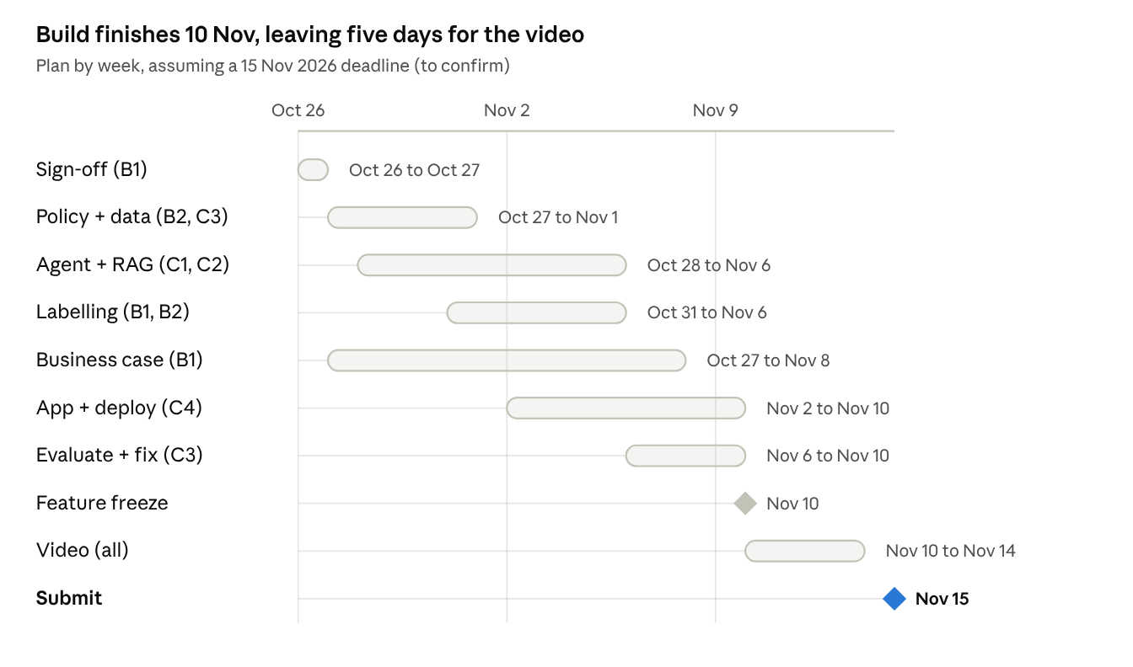
project timeline · 26 Oct to 15 Nov 2026
The deadline is assumed from the old PolicyPatch plan; move every bar if the real date differs. Nothing new is built after the 10 Nov feature freeze, so the last five days go to the video and fixes.

Open questions and next steps
- ☐ Ask the professor: "Would an AI agent that helps Carousell settle 'not as described' disputes on second-hand items count as unique to one industry?" (B1)
- ☐ Confirm the real submission deadline; the timeline below assumes 15 Nov 2026 (B1)
- ☐ Read the full Carousell SG help pages and save them as the policy corpus (B2, C2)
- ☐ Check the Mercari Kaggle competition rules allow reuse outside the competition (C3)
- ☐ Choose the LLM and confirm who pays for API usage: Gemini (taught in class) or OpenAI (C1)
- ☐ Find any public figure on Carousell's dispute volume, fees on 'Buy' button orders, or user numbers (B1)
- ☐ Decide whether a written report is needed besides the video (all)
- ☐ Assign names to the six roles (all)

Sources
- Carousell SG: Buyer Protection and Certified Refund Policy
- Carousell SG: What is Buyer Protection?
- Carousell SG: Overview of the dispute handling process
- Carousell SG: What happens when a refund/return request is raised?
- SPF: Annual Scam and Cybercrime Brief 2025
- SPF: Mid-Year Scam and Cybercrime Brief 2026
- MHA: E-commerce Marketplace Transaction Safety Ratings, Carousell
- Sea Limited Q4 2024 earnings call transcript
- Google Cloud: Carousell customer story
- OneShift: Carousell Autos AI car finder
- Sixth Tone: How Taobao crowdsourced its courts
- Fini: AI platforms for refund, return and dispute automation
- eBay Community: abuse of "not as described" returns
- Towards Data Science: the Mercari Price Suggestion dataset
Carousell's help pages and the SPF briefs were cited from search results; the MHA page and the Sea transcript were read in full.

